Subject: Business For Data Driven Companies

CA3
Report
on
“Cybercrime Trend Analysis and Judicial Performance Evaluation in India using Data Analytics”

Submitted By
Name : Shivansh Lohani
PRN:23070521141
Name: Shreyasi Gidmare
PRN:23070521146
Name: Sushmit Partake
PRN:23070521156

Table of Contents
S. No. | Title | Page No
1 | Abstract | 3
2 | Introduction | 4
3 | Overview | 5
4 | Business Problem Definition | 6
5 | Techniques And Methods | 7
6 | Analytical Problems, Solutions and BDDC Alignment | 10
7 | Analytical Findings from the Study | 11
8 | Trend Analysis Using Visualization | 11
9 | Results and Performance Analysis | 12
10 | Discussion: Alignment with BDDC Concepts | 16
11 | Refrences | 17

Abstract
Cybercrime has emerged as one of the fastest-growing threats in the digital era, especially in countries like India where digital adoption is rapidly increasing. This project presents a comprehensive analysis of cybercrime trends across Indian states from 2021 to 2023, along with an evaluation of judicial performance using conviction rates and pendency percentages.
The study employs data analytics techniques such as data preprocessing, exploratory data analysis (EDA), visualization, and predictive modeling to identify patterns and trends in cybercrime. Regression-based models are used to forecast cybercrime cases for the year 2024. The results indicate a consistent increase in cybercrime cases and highlight inefficiencies in judicial systems, particularly in terms of case backlog and low conviction rates.
An interactive dashboard is developed to visualize trends, comparisons, and predictions, making the findings accessible and easy to interpret. The project provides actionable recommendations for improving cybersecurity infrastructure and judicial efficiency.
Keywords:
Cybercrime, Data Analytics, Predictive Modeling, Judicial Performance, Conviction Rate, Pendency Rate, Machine Learning, Data Visualization, Dashboard, India

1.Introduction
In the contemporary digital era, the rapid growth of internet usage, digital payments, and online services has significantly transformed the way individuals and organizations operate. However, this transformation has also led to a substantial increase in cybercrime activities such as fraud, phishing, identity theft, and hacking. As a result, cybercrime has emerged as a major concern for governments and law enforcement agencies. Organizations and institutions today increasingly rely on data analytics to understand patterns, identify risks, and make informed decisions. In the context of cybercrime, data analytics plays a crucial role in analyzing large volumes of crime data, detecting trends, and improving decision-making processes. This report focuses on the application of data analytics techniques to analyze cybercrime tre nds across India and evaluate judicial performance using key metrics such as conviction rate and pendency percentage. The project demonstrates how data-driven approaches can support effective governance and policy formulation.
1.1 Importance of Data Analytics in Data-Driven Systems
Data analytics enables organizations to convert raw data into meaningful insights that support strategic decision-making. In government systems, data analytics helps in:
- Identifying crime patterns and trends
- Allocating resources effectively
- Improving judicial efficiency
- Supporting evidence-based policymaking
By leveraging data analytics, decision-makers can proactively address challenges and optimize system performance.
1.2 Role of Cybercrime Data and Judicial Analysis
Cybercrime data provides valuable insights into the nature and distribution of digital crimes. However, analyzing such large datasets manually is inefficient and impractical. Therefore, automated data analysis techniques are essential.
Judicial data, including conviction rates and case pendency, helps evaluate the efficiency of the legal system. Combining these datasets allows for a comprehensive analysis of both crime trends and system performance.
Objectives of the Report
- To analyze cybercrime trends using data analytics techniques
- To evaluate judicial performance using key metrics
- To apply predictive modeling techniques for forecasting
- To compare multiple machine learning models
- To demonstrate BDDC concepts through a real-world case study

2. Overview
2.1 Description of the Study
This case study focuses on analyzing cybercrime trends in India over a period of three years (2021–2023) and evaluating judicial performance based on court disposal data. The study applies a combination of statistical analysis, machine learning techniques, and data visualization methods to extract meaningful insights.The project also includes predictive modeling using multiple regression techniques to forecast cybercrime cases for the year 2024. By comparing different models, the study identifies the most suitable approach for prediction.
2.2 Dataset and Problem Context
The datasets used in this study are obtained from official government sources and include:
- State/UT-wise cybercrime data (2021–2023)
- Court disposal data for cybercrime cases (2023)
Each dataset contains attributes such as:
- State/UT name
- Total cybercrime cases
- Cases disposed
- Number of convictions
- Pending cases
The primary problem addressed in this study is to analyze trends, evaluate system performance, and predict future cybercrime cases using data analytics techniques.
Goal of the Study
- To identify patterns in cybercrime data
- To evaluate judicial efficiency
- To compare predictive models
- To forecast future cybercrime trends

3. Business Problem Definition
In modern governance systems, cybercrime management has become a complex and critical challenge due to the rapid expansion of digital technologies and online services. With the increasing adoption of digital platforms for communication, banking, e-commerce, and public services, the volume and diversity of cybercrime incidents have grown significantly. This has placed substantial pressure on law enforcement agencies and judicial systems to effectively manage, analyze, and respond to cybercrime cases.
One of the primary challenges faced by authorities is the rapid increase in cybercrime cases over time. The growing number of incidents makes it difficult to monitor trends and identify high-risk regions using traditional methods. Additionally, the diversity of cybercrime types, such as phishing, fraud, hacking, and identity theft, further complicates the analysis process.
Another major issue is the high pendency of cases in the judicial system. Due to limited resources, lack of specialized cybercrime expertise, and increasing case loads, many cases remain unresolved for long periods. This leads to delays in justice delivery and reduces the overall effectiveness of the legal system.
Furthermore, low conviction rates highlight inefficiencies in investigation and prosecution processes. Cybercrime cases often involve complex digital evidence, making it difficult to achieve successful convictions. This undermines public confidence in the system.
In addition, limited resources for law enforcement agencies restrict their ability to handle large volumes of data and respond effectively to emerging cyber threats. Manual analysis of large datasets is inefficient and prone to errors.
To address these challenges, there is a need for a data-driven analytical system that can:
- Efficiently process and analyze large-scale cybercrime datasets
- Identify patterns, trends, and anomalies in crime data
- Evaluate judicial performance using key metrics
- Support predictive analysis for future planning
- Assist decision-makers in resource allocation and policy formulation
The analytical problem addressed in this project is the development of such a data-driven system using data analytics and machine learning techniques. This approach aligns with Business for Data-Driven Companies (BDDC) concepts, particularly predictive analytics, performance analysis, and decision support systems, which enable organizations to make informed and strategic decisions based on data.

4. Techniques and Methods
4.1Methodology Explanation
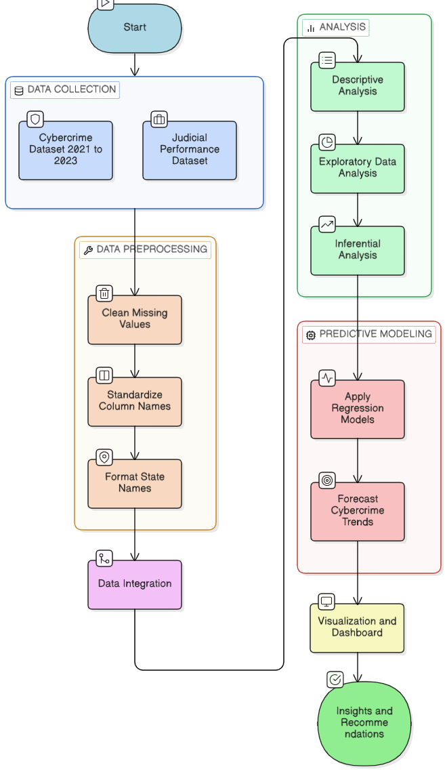
Fig: Flowchart

The project follows a structured data analytics pipeline:
- Data Collection
  - Cybercrime dataset (2021–2023)
  - Judicial performance dataset
- Data Preprocessing
  - Cleaning missing values
  - Standardizing column names
  - Formatting state names
- Data Integration
  - Merging datasets for combined analysis
- Descriptive Analysis
  - Calculating totals, averages, trends
- Exploratory Data Analysis (EDA)
  - Visualizing patterns and distributions
- Inferential Analysis
  - Studying relationships using correlation
- Predictive Modeling
  - Applying regression models
  - Forecasting cybercrime trends
- Visualization & Dashboard
  - Creating interactive graphs using Plotly
- Insights & Recommendations
  - Generating actionable conclusions
4.2 Data Preprocessing
Data preprocessing is a critical step in the data analytics pipeline, as the quality of the analysis depends heavily on the quality of the input data. Real-world datasets often contain inconsistencies, missing values, and formatting issues that must be addressed before analysis.
The preprocessing steps performed in this project include:
- Handling Missing Values: Missing or incomplete data entries are identified and either removed or appropriately handled to ensure accuracy.
- Standardization of Column Names: Column names are cleaned and standardized using functions to ensure consistency across datasets. For example, spaces and special characters are removed and replaced with uniform naming conventions.
- Data Type Conversion: Data fields such as numerical values are converted into appropriate formats (e.g., integer or float) to enable accurate calculations and analysis.
- Duplicate Removal: Duplicate records are identified and removed to avoid bias in analysis.
- Data Integration: Multiple datasets, including cybercrime data and judicial performance data, are merged based on common attributes such as state/UT.
These preprocessing steps ensure that the dataset is clean, structured, and ready for further analysis, thereby improving the reliability of the results.
4.3 Exploratory Data Analysis (EDA)
Exploratory Data Analysis (EDA) is performed to understand the structure of the data and identify underlying patterns and relationships. It serves as a foundation for further analysis and modeling.
The following techniques are used in EDA:
- Line Graphs: Used to analyze year-wise trends in cybercrime cases, showing how crime levels change over time.
- Bar Charts: Used for state-wise comparison, highlighting differences in cybercrime distribution across regions.
- Scatter Plots: Used to study relationships between variables such as cybercrime cases and pendency rates.
- Correlation Analysis: Used to measure the strength and direction of relationships between variables.
EDA helps in identifying important insights such as growth trends, regional disparities, and potential correlations, which guide the selection of appropriate predictive models.
4.4 Machine Learning Models
To perform predictive analysis, the project uses three different machine learning models, each with varying levels of complexity:
Linear Regression
Linear Regression is a basic statistical model used to establish a linear relationship between independent and dependent variables. In this project, it is used to model the relationship between time (year) and cybercrime cases.
- Purpose: To capture simple increasing trends
- Advantage: Easy to interpret and implement
- Limitation: Cannot model non-linear patterns
Polynomial Regression
Polynomial Regression extends linear regression by introducing higher-degree terms, allowing it to capture curved trends.
- Purpose: To model accelerating or non-linear growth in cybercrime
- Advantage: More flexible than linear regression
- Limitation: Can overfit when dataset is small

Random Forest Regressor
Random Forest is an ensemble learning method that combines multiple decision trees to improve prediction accuracy.
- Purpose: To capture complex and non-linear relationships
- Advantage: High accuracy and robustness
- Limitation: Requires more data and computational resources
4.5 Model Comparison
The performance of the models is evaluated using metrics such as:
- R² Score: Measures how well the model explains the variability in data
- Prediction Accuracy: Measures the closeness of predicted values to actual values
By comparing these metrics, the most suitable model is selected for forecasting cybercrime trends.
Model | Complexity |  | Type |  | Purpose
Linear Regression | Low |  | Linear |  | Basic trend
Polynomial Regression | Medium |  | Non-linear |  | Curved trend
Random Forest | High |  | Ensemble  ML |  | Complex pattern

5. Analytical Problems, Solutions and BDDC Alignment
5.1 Problem: Increasing Cybercrime Trends
The continuous rise in cybercrime makes it difficult to monitor and control crime effectively.
Solution: Trend analysis using visualization techniques such as line graphs.
BDDC Alignment: Predictive Analytics – using historical data to understand and anticipate future trends.
5.2 Problem: Judicial Inefficiency
High pendency and low conviction rates indicate inefficiencies in the judicial system.
Solution: Analysis of conviction rate and pendency percentage.
BDDC Alignment: Performance Analytics – evaluating system efficiency using key performance indicators.
5.3 Problem: Data Complexity
The dataset contains large volumes of structured data, making analysis challenging.
Solution: Data preprocessing and integration techniques.
BDDC Alignment: Data Management – organizing and preparing data for analysis.
5.4 Problem: Prediction of Future Cases
Authorities need to anticipate future cybercrime trends for better planning.
Solution: Regression-based predictive models.
BDDC Alignment: Forecasting – predicting future outcomes using historical data.
5.5 Problem: Decision Making
Lack of clear insights makes decision-making difficult.
Solution: Interactive dashboard and visualization tools.
BDDC Alignment: Business Intelligence – converting data into actionable insights.

6. Analytical Findings from the Study
The analysis reveals several important insights:
- Cybercrime cases show a consistent upward trend, indicating increasing digital threats.
- Certain states contribute significantly to total cases, highlighting regional disparities.
- Conviction rates are relatively low, suggesting inefficiencies in prosecution.
- Pendency rates are high, indicating backlog in the judicial system.
- Predictive models indicate that cybercrime is likely to increase in the future, requiring proactive measures.
7. Trend Analysis Using Visualization
Visualizations play a key role in understanding the data:
- Year-wise trend graphs clearly show the increase in cybercrime cases.
- State-wise bar charts highlight uneven distribution across regions.
- Scatter plots reveal relationships between cybercrime and pendency rates.
- Correlation analysis indicates that higher crime often leads to higher backlog.
These visualizations simplify complex data and make it easier to interpret patterns.

8. Results and Performance Analysis
The performance of the predictive models is evaluated based on their ability to capture trends in cybercrime data and provide accurate forecasts. Three models—Linear Regression, Polynomial Regression, and Random Forest Regressor—are used for analysis.
Linear Regression serves as the baseline model and effectively captures the overall increasing trend in cybercrime cases. It is simple and easy to interpret, but its limitation is that it can only model linear relationships and cannot capture complex patterns.
Polynomial Regression improves upon the linear model by capturing non-linear trends. It provides a better fit for the data, especially when cybercrime growth shows acceleration over time. However, due to the small dataset, there is a risk of overfitting.
Random Forest Regressor is an advanced model that can capture complex and non-linear relationships using multiple decision trees. While it is more flexible, its performance is limited in this study because the dataset contains only a few data points.
The models are compared using the R² score, and the model with the highest value is selected as the best-performing model.

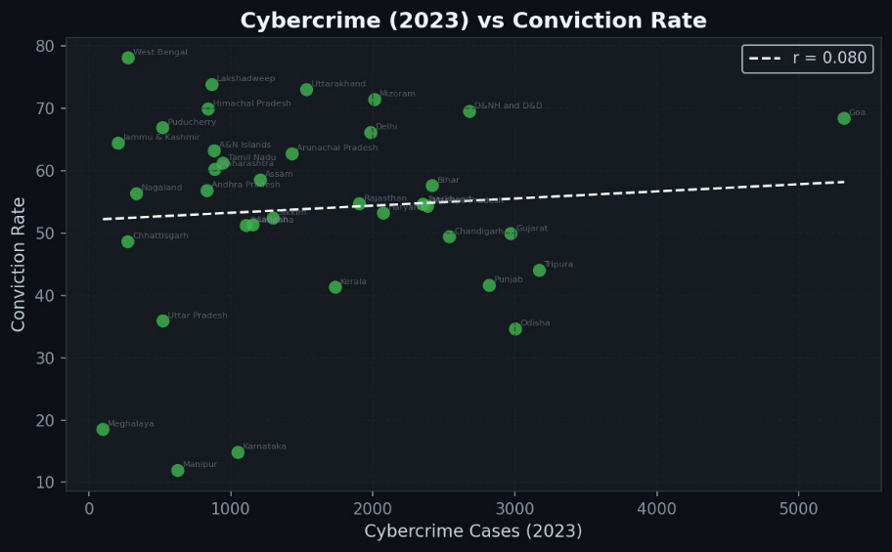

Fig: Relationship between Cybercrime Cases (2023) and Conviction Rate across Indian States

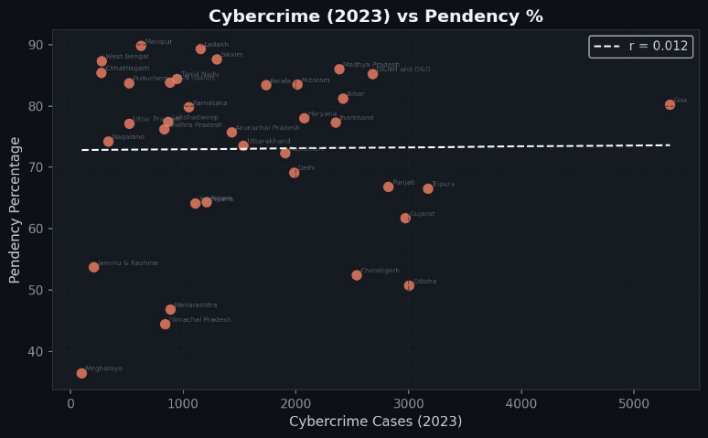

Fig: Relationship between Cybercrime Cases (2023) and Pendency Percentage across Indian States
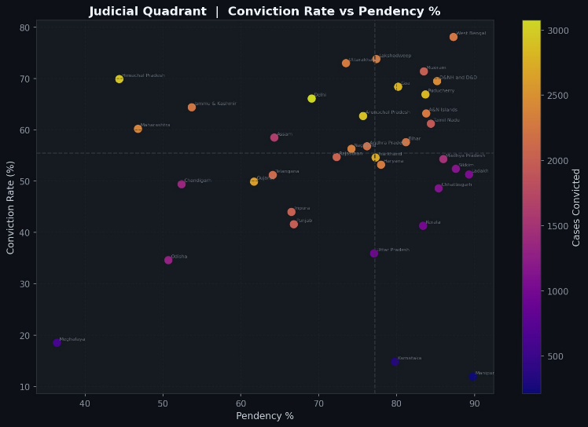

Fig: Judicial Quadrant Analysis showing relationship between Conviction Rate and Pendency Percentage across Indian states.
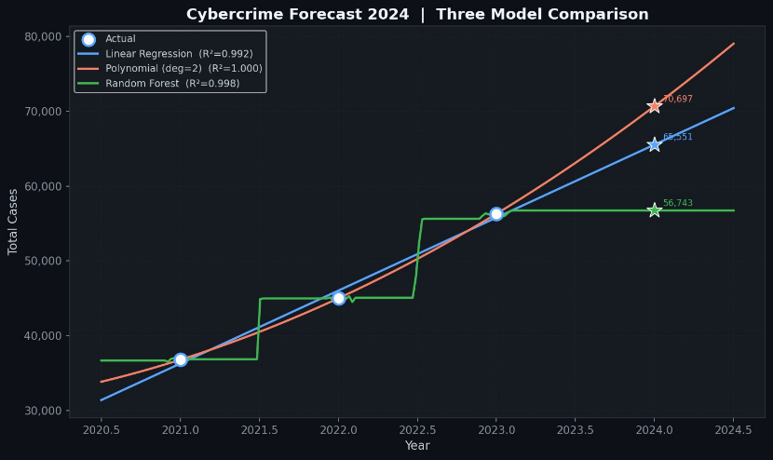

Fig: Cybercrime Forecast for 2024 using Linear Regression, Polynomial Regression, and Random Forest model

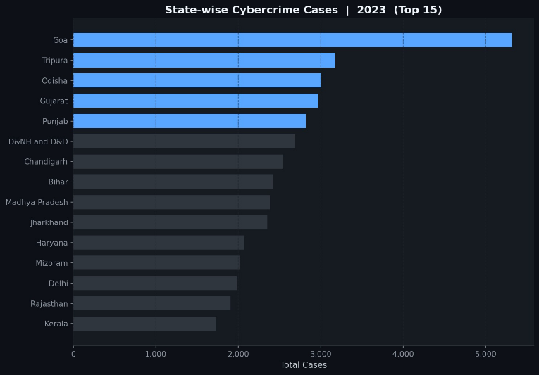

Fig: State-wise Case Pendency Percentage for Cybercrime Cases in 2023
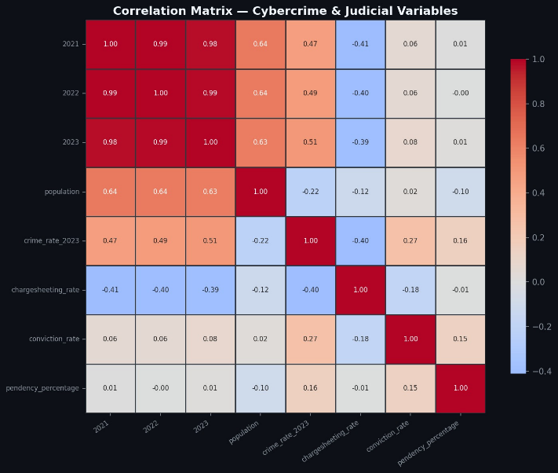

Fig: Correlation matrix of cybercrime and judicial performance variables
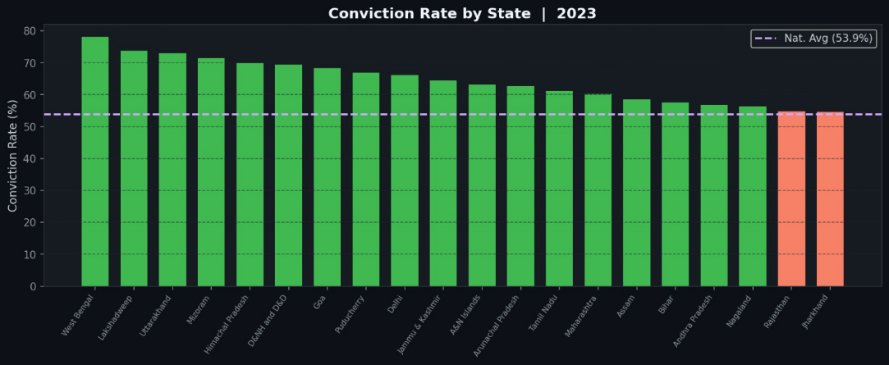

Fig: State-wise Conviction Rate for Cybercrime Cases in 2023

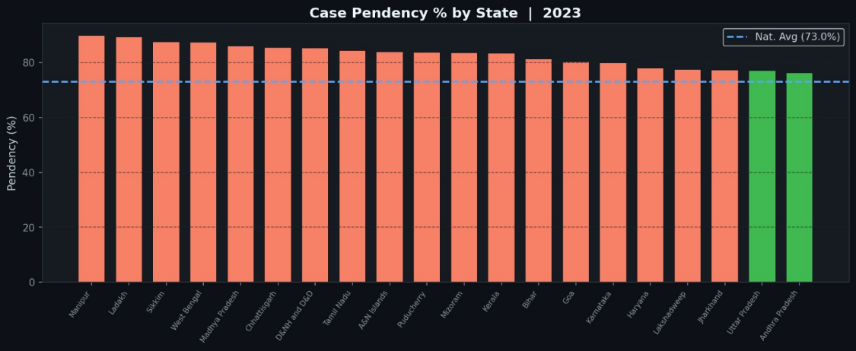

Fig: Top 15 states by cybercrime cases in India for 2023
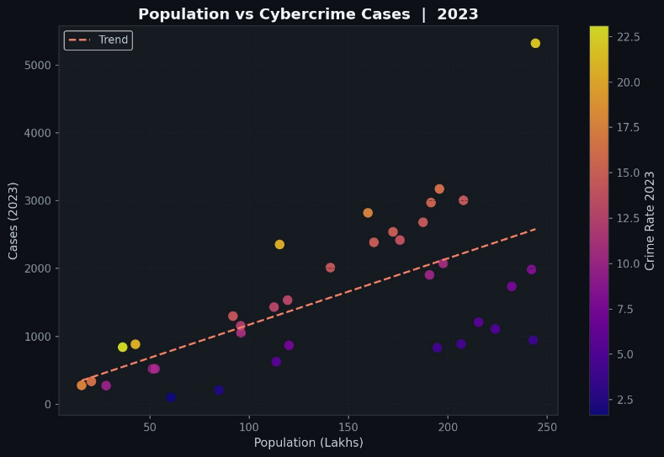

Fig: Relationship between Population and Cybercrime Cases in 2023
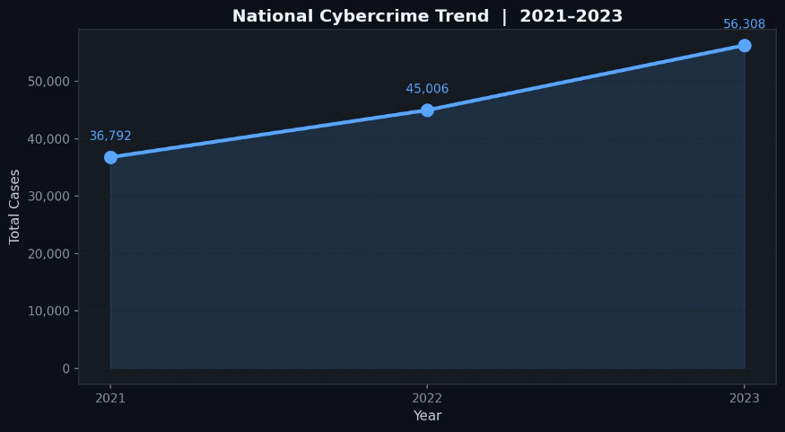

Fig: National Cybercrime Trend in India from 2021 to 2023

9. Discussion: Alignment with BDDC Concepts
This project demonstrates the application of key BDDC concepts by using data analytics to support decision-making in cybercrime management.
Predictive Analytics is applied through machine learning models to forecast future cybercrime trends, helping authorities plan preventive measures.
Data Management is demonstrated through preprocessing and integration of datasets, ensuring data quality and consistency.
Segmentation Analysis is performed by comparing cybercrime across different states, allowing identification of high-risk regions.
Data Visualization is used to represent trends and patterns through graphs and dashboards, making complex data easy to understand.
Decision Support Systems are implemented through insights generated from analysis and prediction, enabling informed decision-making by stakeholders.
Overall, the project highlights how data can be used as a strategic asset to improve efficiency, support policy decisions, and enhance governance systems in line with BDDC principles.
10. Conclusion
This project analyzes cybercrime trends and judicial performance in India using data analytics techniques. The study shows a consistent increase in cybercrime cases and highlights issues such as high pendency and low conviction rates.Predictive models like Linear Regression, Polynomial Regression, and Random Forest indicate that cybercrime is expected to rise further. The project demonstrates how data-driven approaches can support decision-making and improve system efficiency.Overall, it highlights the importance of using analytics for better governance and planning.

11. References
- Government of India Open Data Portal
  - State/UT-wiseCyberCrimes(2021–2023) https://www.data.gov.in/resource/stateut-wise-cyber-crimes-2021-2023

  - Court Disposal of Cybercrime Cases (2023)
https://www.data.gov.in/resource/stateut-wise-court-disposal-cyber-crime-cases-during-2023
- Python Libraries Used
  - NumPy
  - Pandas
  - Matplotlib
  - Seaborn
  - Plotly
  - Scikit-learn
- Concepts and Techniques
  - Data Analytics
  - Machine Learning (Regression Models)
  - Predictive Analytics
  - Data Visualization
  - Business Intelligence
- Academic References
  - Introduction to Machine Learning and Data Mining Concepts
  - Research papers and online resources on cybercrime analysis and predictive modeling

